NAME:VENKATRAMAMOORTHY.G
- Build a row or column of boxes inside a flex container and control their alignment, spacing, and layout direction using Flexbox.
CODE:
<!doctype html>
<html lang="en">
<head>
<meta charset="UTF-8" />
<meta name="viewport" content="width=device-width, initial-scale=1.0" />
<title>Document</title>
<style>
.main {
width: 100%;
height: 70vh;
background-color: lightblue;
display: flex;
gap:10px;
padding: 20px;

}
.box1 {
width: 100px;
height: 100px;
background-color: white;
border-radius: 10px;
border: 2px solid black;
margin: 5px;
padding: 5px;
}
.box2 {
width: 100px;
height: 100px;
background-color: white;;
border-radius: 10px;
border: 2px solid black;
margin: 5px;
padding: 5px;
}
.box3 {
width: 100px;
height: 100px;
background-color: white;
border-radius: 10px;
border: 2px solid black;
margin: 5px;
padding: 5px;
}
</style>
</head>
<body>
<div class="main">
<div class="box1">
<p>box 1</p>
</div>
<div class="box2">
<p>box 2</p>
</div>
<div class="box3">
<p>box 3</p>
</div>
</div>
</body>
</html>

OUTPUT:
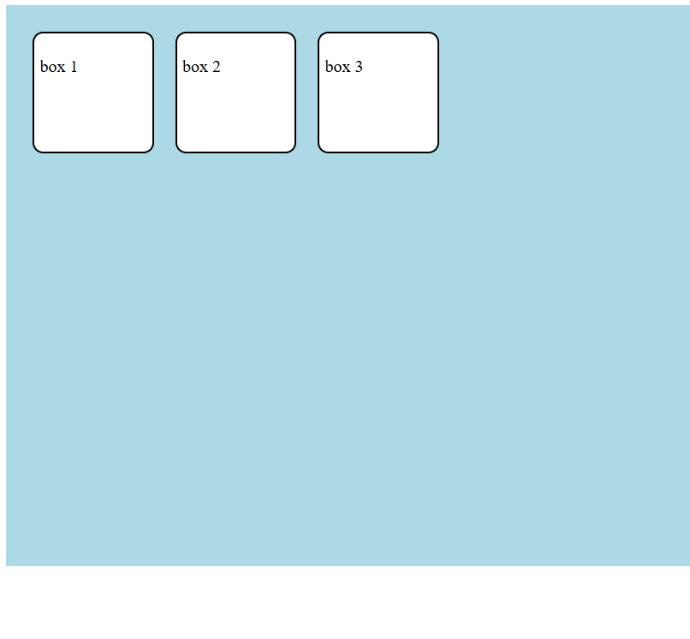
- Create a web layout with a flex container that holds 3 child boxes.
CODE:
<!doctype html>
<html lang="en">
<head>
<meta charset="UTF-8" />
<meta name="viewport" content="width=device-width, initial-scale=1.0" />
<title>Document</title>
<style>
.main {
width: 100%;
height: 70vh;
background-color: lawngreen;
display: flex;
align-items: center;
justify-content: center;
padding: 10px;
}
.box1 {
width: 100px;
height: 100px;
background-color: antiquewhite;
border-radius: 10px;
border: 2px solid black;
margin: 5px;
display: flex;
align-items: center;
justify-content: center;
}
.box2 {
width: 100px;
height: 100px;
background-color: aquamarine;
border-radius: 10px;
border: 2px solid black;
margin: 5px;
display: flex;
align-items: center;
justify-content: center;
}
.box3 {
width: 100px;
height: 100px;
background-color: rgb(140, 122, 255);
border-radius: 10px;
border: 2px solid black;
margin: 5px;
display: flex;
align-items: center;
justify-content: center;
}
</style>
</head>
<body>
<div class="main">
<div class="box1">
<p>box 1</p>
</div>
<div class="box2">
<p>box 2</p>
</div>
<div class="box3">
<p>box 3</p>
</div>
</div>
</body>
</html>

OUTPUT:
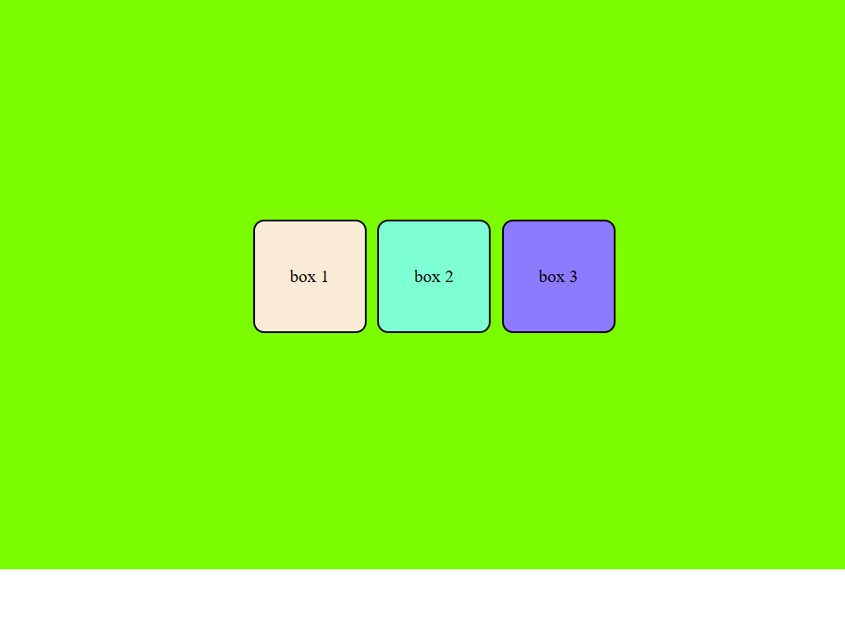
- Use the following Flexbox properties to:
Display the container as a flexbox.
Set the direction (row or column).
Adjust horizontal alignment using justify-content.
Adjust vertical alignment using align-items.
Add spacing between items using gap.
CODE:
<!DOCTYPE html>
<html lang="en">
<head>
<meta charset="UTF-8">
<meta name="viewport" content="width=device-width, initial-scale=1.0">
<title>Document</title>
<style>
table{
width: 100%;
}
h1{
color:blueviolet;
text-shadow: 3px 3px 5px;
font-weight: 300;
}
.main{
width: 100%;
height: 70vh;
background-color: lightcoral;
display: flex;
align-items: center;
justify-content: center;
padding:10px;
border-radius: 10px;
border: 2px solid black;
box-shadow: 3px 3px 5px;
gap:10px;
flex-direction: column;
}
.box1{
width: 100px;
height:100px;
background-color: antiquewhite;
border-radius: 10px;
border: 2px solid black;
box-shadow: 3px 3px 5px;
margin:5px;
display: flex;
align-items: center;
justify-content: center;

}
.box2{
width: 100px;
height:100px;
background-color: lightseagreen;
border-radius: 10px;
border: 2px solid black;
box-shadow: 3px 3px 5px;
margin:5px;
display: flex;
align-items: center;
justify-content: center;
}
.box3{
width: 100px;
height:100px;
background-color: lightsalmon;
border-radius: 10px;
border: 2px solid black;
box-shadow: 3px 3px 5px;
margin:5px;
display: flex;
align-items: center;
justify-content: center;
}
p{
font-family: 'Courier New', Courier, monospace;
font-weight: 800;
color: darkolivegreen;
text-shadow: 2px 2px 5px;
text-align: center;
}
hr{
height: 5px;
width: 100%;
background-color: black;
}
</style>
</head>
<body>
<table>
<thead>
<tr>
<th>
<h1>this is box model and flex</h1>
<hr>
</th>
</tr>
</thead>
<tbody>
<tr>
<td>
<div class="main">
<div class="box1">
<p>box 1</p>
</div>
<div class="box2">
<p>box 2</p>
</div>
<div class="box3">
<p>box 3</p>
</div>
</div>
</td>
</tr>
</tbody>
<tfoot>
<tr>
<td>
<p>@ copyright 2026</p>
</td>
</tr>
</tfoot>
</table>
</body>
</html>

OUTPUT:
